CSE331: Automata and Computability
Assignment 02

Solve all the questions given below:

- List five use cases for applying the knowledge from our CSE331 course. Describe in detail.

- Proof L is a non-regular language using the Pumping Lemma: [If you are not seeing any Qs, then View in the light theme]

  - L = {w ∈ {a,b}∗: w = a^{i}b^{j}, where i > j, and j ≥ 0}

- Design a Context Free Grammar for the Language:

  - L = {w ∈ {a,b,c,p,q,r,#}*: a^{i}#^{n}c^{j}p^{2x}q^{y}r^{z}b^{k} where i=j+k, y=3x+z, z is even, n is odd, and i,j,k,n,x,y,z ≥ 0}
  - L = {w ∈ {0,1,2}*: w = 0^{i}2^{j}1^{k}, [where ……conditions…… ] }
where…
    - i = k, i,k ≥ 1 and j ≥ 2
    - i = 3k, j is odd, and i,j,k ≥ 0
    - i is a multiple of two, k is two more than a multiple of 3, j = k+i, and i,j,k ≥ 0
    - i+j > k and i,j,k ≥ 0
    - i+k is even, j = i+k and j≥1
  - L = {w ∈ {0,1}*: the parity of 0s and 1s is different in w}
  - L = {w ∈ {0,1}*: the number of 0s and 1s are different in w}
[Hint: First, try to solve for an equal number of 0s and 1s in w]
  - L = {w ∈ {a, b}∗: w is a palindrome}. Design a CFG for 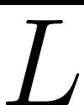 (Complement of L)
  - L = {w ∈ {a, b}∗: w does not contain any palindromic substring of length two}
  - L = {w#x | w^{R} is a substring of x where w ∈ {0, 1}∗}. w^{R} Denotes reverse of string, w.
  - L = {1^{i}02^{j}1^{k}| i, j, k ≥ 0, 3i ≥ 4k + 2, j is not divisible by three}
  - Recall that for a string w, |w| denotes the length of w. Σ = {0,1}
L1 = {w ∈ Σ∗: w contains exactly two 1s}
L2 = {x#y : x ∈ Σ∗, y ∈ L1, |x| = |y|}
Construct a CFG for L2.
  - Recall that for a string w, |w| denotes the length of w. Σ = {0,1}
L1 = {w ∈ Σ∗: w contains at least three 1s}
L2 = {x#y : x ∈ (ΣΣ)∗, y ∈ L1, |x| = |y|}
Construct a CFG for L2.
  - Recall that for a string w, |w| denotes the length of w. Σ = {a,b}
L1 = {w ∈ Σ∗: w contains bb as a substring}
L2 = {w1#w2 : w1, w2 ∈ L1 and |w1| = |w2|}
Construct a CFG for L2.

- For all the problems in Question(3), now construct the Pushdown Automata (PDA).

- Derivation, Parse Tree, Ambiguity

i) Given the Context-Free Grammar, answer the following questions

A → A1 | 0A1 | 01

(a) Give a leftmost derivation for the string 001111.
(b) Sketch the parse tree corresponding to the derivation you gave in (a).
(c) Demonstrate that there are two more parse trees (apart from the one you already found in (b)) for the same string.
(d) Find a string w of length six such that w has exactly one parse tree in the grammar above. (1 point)

ii) Given the Context-Free Grammar, answer the following questions:

A → 1A | 1C | 0B | 00A
B → 0A | 1B | 00B
C → 0C0 | 0C1 | 1C0 | 1C1 | ε

(a) Give a leftmost derivation for the string 01011001. (3 points)
(b) Sketch the parse tree corresponding to the derivation you gave in (a). (2 points)
(c) Demonstrate that the given grammar is ambiguous by showing two more parse trees (apart from the one you already found in (b)) for the same string. (3 points)
(d) Find a string w of length six such that w has exactly one parse tree in the grammar above. (1 point)
(e) Design an unambiguous Context Free Grammar for the language represented by the given ambiguous grammar. (1 point)

- Turing Machine
- L = {$1^{3^{n}}| n ≥ 0$}
- L = {w ∈ {0,1,2}*:0^{i}1^{j}2^{k} where i=j=k and i,j,k ≥ 0}
- L = {w ∈ {0,1,2}*:0^{i}#1^{j}#2^{k} where i*j=k and i,j,k ≥ 0} [Idea described in Sipser’s Book]
- L = {w ∈ {a,b}*: w is an odd length palindrome}
- L = {w#w^{R}#w | w ∈ {a,b}*} [w^{R} means reverse of w]
- Let HALT_TM = { <M, w>: M is a TM and M halts on input w }.
Given that HALT_TM is undecidable, prove that the collection of Turing-recognizable languages is not closed under complement.

—----------------------------------------------------------------------
—----------------------------------------------------------------------

CSE331: Automata and Computability
Practice Sheet
Prepared By: KKP

Question 1: Designing Context-Free Grammar

Give Context-free Grammar that generates the language

- L = {w ∈ {0,1}*: w starts with ‘0’ and the length of w is even.}
- L = {w ∈ {a,b}*: every second letter in w is a ‘b’.}
- L = {w ∈ {a,b}*: the length of w is divisible by three}
- L = {w ∈ {0,1}*: w starts with and ends with a different symbol.}
- L = {w ∈ {a,b}*: the number of ‘a’ is at least the number of ‘b’ in w.}
- L = {w ∈ {a,b}*: the length of w is two more than a multiple of six}
- L = {w ∈ {0,1}*: w = 0^{n}1^{2n+3}, n ≥ 0 }
- L = {w ∈ {0,1}*: w = 0^{n}1^{n}, where n is odd.}
- L = {w ∈ {0,1,2}*: w=0^{i}1^{j}2^{k} where j ≥ 2i + 3k, and i, k ≥ 0}
- L = {w ∈ {0,1,2,3}*: w=0^{i}1^{j}2^{k}3^{m} where i=m, j ≥ 3k+2, and m, k ≥ 0}
- L = {w ∈ {0,1,2}*: w=0^{i}1^{j}2^{k} where i > 2j + 3k, and j, k ≥ 0}
- If A = {w ∈ {0, 1}* : w contains at least two 0s}, then construct L = {w ∈ {0, 1}∗: w = 0^{3i}v1^{2i} where v ∈ A and i ≥ 0} [marked as problem j in the solution]
- Recall that for a string w, |w| denotes the length of w. Σ = {0,1}
L1 = {w ∈ Σ∗: w contains 11}
L2 = {x#y : y ∈ L1, x ∈ Σ∗, |x| = |y|}
Construct a CFG for L2.
- L = {w ∈ {0,1}* : w₁#w₂: number of 0s w₁ is equal to number of 1s in w₂.}
- L = {w ∈ {0,1}* : w₁#w₂: length of w₂ is double of length of w₁.}

Construct a Context-free Grammar for the language expressed by the following Finite Automata:

- Convert the Regular Expression into a CFG: ( (ab)* + (a+b³) cb)*
- Convert the Regular Expression into a CFG: ( a*b* + (ac+b*c) b)*
- Convert the following DFA into a CFG:
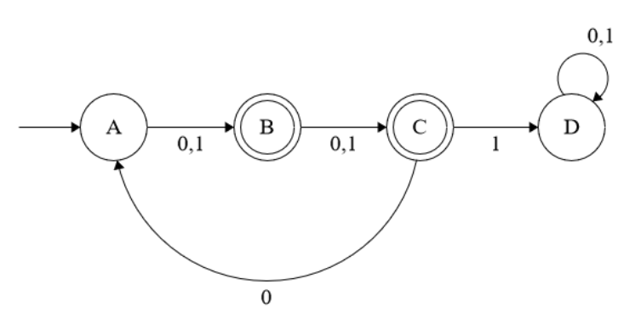

Question 2: Derivation, Parse tree, Ambiguity

S→ASB|SS|SAS|A
A→ASS|BS|B
B→00|11|01|1

Given the above Context-Free Grammar, answer the following questions:

a) Show the Leftmost Derivation of 00010111
b) Sketch the parse tree corresponding to the derivation you gave in (a).
c) Show the Rightmost Derivation of 00010111
d) Sketch the parse tree corresponding to the derivation you gave in (c).

- S → 0S1 | 1S0 | SS | 01 | 10

Given the above Context-Free Grammar, answer the following questions:

a) Show that the grammar above is ambiguous by demonstrating two different parse trees for 011010.
b) Find a string w of length six such that w has exactly one parse tree in the grammar above.

Question 3: Pushdown Automata

- L = { w ∈ {0,1}* : w = 0^{n}1^{n}, where n is odd.}
- L = { w ∈ {0,1}* : w = 0^{m}1^{n}, where m,n ≥ 1 and m≥n.}
- L = { w ∈ {0,1}*: w | the length of w is divisible by four}
- L1 = { w ∈ {0,1}*: the number of 1s in w is multiple of 3.}
L2 = { w ∈ {0,1}* : w contains even numbers of 0.}
Construct a PDA for L = { w ∈ {0,1}*: w = uv, where u ∈ L1,v ∈ L2 and |u| = |v| }
- L = { w ∈ {0,1}* : w = 0^{i}1^{j}0^{k}, where j = i+k and i, k ≥ 0.}
- L = { w ∈ {0,1}* : w = 0^{i}1^{j}0^{k}, where i+j = k and i, k ≥ 0.}
- L = { w ∈ {0,1}* : w₁#w₂: number of 00 substrings in w₁ is equal to number of 11 in w₂.}
- L = { $w{\underline{w}}^{R}$: w ∈ {0,1}* }
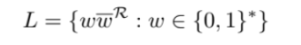
Here, ${\underline{w}}^{R}$ denotes the reverse complement of the string w.
For example, $01001101 ∈ L$, because the second half of the string, $1101$, is the reverse complement of the first half, $0100$, i.e. $1101 ={\underline{0100}}^{R}$

